KUTU’S TCPDUMP REPORT (Kali Linux)

Introduction
Tcpdump is a command-line network packet analyzer available on Kali Linux and other Unix-like operating systems. It is used to capture, monitor, and analyze network traffic in real time. Cybersecurity professionals, network administrators, and penetration testers use Tcpdump to troubleshoot network issues, monitor communications, detect suspicious activities, and collect packet data for forensic investigations. Captured packets can also be saved in a .pcap file and analyzed later using tools such as Wireshark.

Purpose of Tcpdump
The primary purpose of Tcpdump is to monitor and analyze network traffic. It helps users identify network problems, verify network configurations, detect malicious or unusual activities, troubleshoot connectivity issues, and capture evidence for cybersecurity investigations.

Common Commands
- tcpdump -D – Displays all available network interfaces.
- sudo tcpdump -i eth0 – Captures all packets on the eth0 interface.
- sudo tcpdump -i eth0 -c 10 – Captures only 10 packets before stopping.
- sudo tcpdump -i eth0 -n – Displays IP addresses without resolving hostnames.
- sudo tcpdump -i eth0 tcp – Captures only TCP traffic.
- sudo tcpdump host 8.8.8.8 – Captures traffic to or from the specified IP address.
- sudo tcpdump -i eth0 -w capture.pcap – Saves captured packets to a file.
- tcpdump -r capture.pcap – Reads and displays packets from a saved capture file.

Practical Activity
For this exercise, I opened the Kali Linux terminal and used the command tcpdump -D to view the available network interfaces. I then started capturing packets on the eth0 interface using sudo tcpdump -i eth0 -n -c 20, which captured the first 20 packets while displaying IP addresses without resolving hostnames. After starting the capture, I generated network traffic by visiting a website in a web browser. Tcpdump successfully displayed packet details, including the source IP address, destination IP address, protocol, and TCP flags. Finally, I saved the captured packets using sudo tcpdump -i eth0 -w mycapture.pcap so they could be analyzed later with Wireshark.

Conclusion
Tcpdump is a powerful and efficient packet capture tool that enables users to monitor and analyze network traffic directly from the command line. During this practical exercise, I successfully captured, viewed, and saved network packets generated while browsing the internet. The exercise demonstrated that Tcpdump is an essential tool for network troubleshooting, cybersecurity analysis, penetration testing, and digital forensic investigations because it provides detailed insight into network communications.
Below is the Results generated using the using sudo tcpdump -i eth0 -n -c 20 command

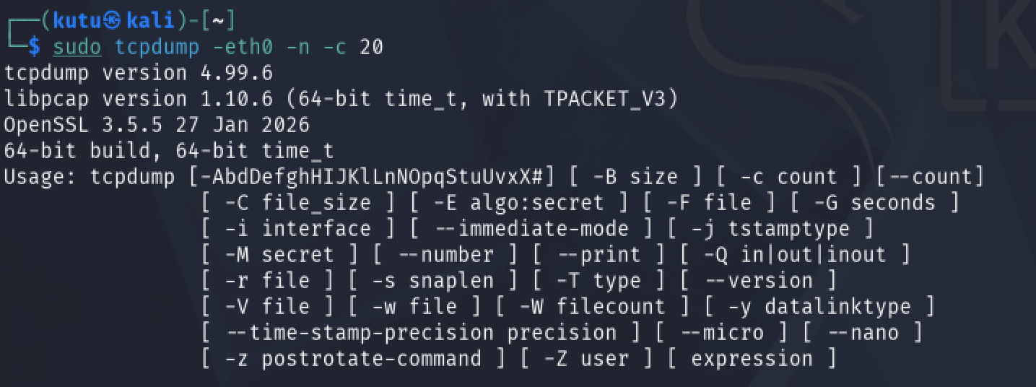
Here are some of the screenshots of the results I got when working on the first assignment;
